Virtual Machine Installation

In-class Lab 1 – Report

{Your Name}

IT-120

Marymount University

List of Figures

Figure 1 - Virtual Box 2

Figure 2 - Ubuntu 3

1. Screenshot of Virtual Machine

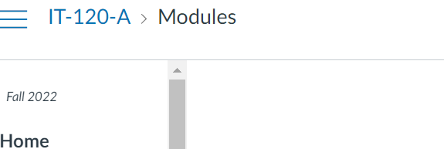

Figure - Virtual Box

1. Screenshot of Running Ubuntu



Figure - Ubuntu